**Appendix: The Effect of Indwelling Arterial Catheters in Hemodynamically Stable Patients With Respiratory Failure: A Propensity Score Analysis**

**A. Construction of Propensity Score Model**

In this study, a propensity score model was developed to estimate likelihood of getting an IAC placement. To construct the model, we first identified an initial set of 53 covariates that potentially influence the decision for IAC placement. We then employed a Genetic Algorithm (GA) based method to shortlist a subset of covariates that optimize the performance of the propensity score model.

**A.1 Covariates Identification based on Clinical Knowledge**

The initial set of 53 covariates is as follows.

Demographic:Admission age, gender, race, daytime admission (7am to 7pm), day of admission and service unit (medical or surgical ICU), and admission Sequential Organ Failure Assessment (SOFA) score.

Co-morbidities (ICD-9): Congestive Heart Failure 398.91 428.0 428.1 428.20 428.21 428.22 428.23 428.30 428.31 428.32 428.33 428.40 428.41 428.42, 428, 428.2, 428.3, 428.4, 428.43, 428.9; Atrial fibrillation 427.3*; Chronic renal disease 585.*; Chronic liver disease 571*; Chronic Obstructive Pulmonary Disease 490-496; Coronary Artery Disease 414.*; Stroke 440-434; Malignancy 140-239; non-COPD lung disease (including acute respiratory distress syndrome) 518*, and Pneumonia 482*.

Vital sign/Hemodynamic variables: Data include weight, mean arterial pressure (MAP), temperature, heart rate, oxygen saturation (SpO2) and central venous pressure (CVP).

Laboratory test results: White blood cell (WBC) count, hemoglobin, platelet count, sodium, potassium, bicarbonate, chloride, blood urea nitrogen (BUN), creatinine, glucose, calcium, magnesium, phosphate, aspartate Aminotransferase (AST), alanine Aminotransferase (ALT), lactic acid dehydrogenase (LDH), total bilirubin, alkaline phosphatase, albumin, troponin T, creatinine kinase, brain natriuretic peptide (BNP), lactate, pH, central venous oxygen saturation (ScVO2), arterial partial pressure of oxygen (PaO2) and arterial partial pressure of carbon dioxide (PCO2).

Sedative medication use, including midazolam, fentanyl, and propofol.

**A.2 Genetic Algorithm-based Covariate Selection and Model Optimization**

A GA-based algorithm was employed to select the subset of covariates that optimizes the performance of the propensity score model.

The genetic algorithm (GA) is a heuristic algorithm inspired by a natural “survival of the fittest” selection process [1]. The GA is commonly adopted for optimization and variable selection problems, and has a wide application in computational biology, engineering, economics, manufacturing, physicals, and mathematics. This method starts with a population of candidate solutions to an optimization problem, and then gradually evolves towards better solutions through an iterative process. Through the iterative process, the “fitness” of all candidate solutions or variable subsets is evaluated based on optimization criteria, and “fitter” solutions will be selected to remain and contribute to the next generation of solutions. The selected solutions based on the fitness function then randomly “mutate” (change a variable) or “breed” (exchange smaller subsets of variables with one another) to generate a new set of candidate solutions for the next iteration. The evolution/optimization process stops when the maximum numbers of iterations or best possible solution has been achieved.

In our study, the GA R package was used to implement the optimization method [2]. We allowed the GA algorithm to evolve over 3000 iterations with 50 candidate solution sets. The GA-based optimization was guided by the following criteria:

* Maximize the average area under the receiver operating characteristic (ROC) curves of the model over a 10-fold cross validation.
* Select a minimum set of covariates for the optimum performance
* Covariates with large amount of missing data are less favorable

**A.3 Final Propensity Score Model**

The final propensity score model consists of 29 covariates as shown in eTable 1. Covariates used in the propensity model building process in pre- and post- matched IAC and non-IAC groups are displayed in eTable 2 and eFigure 1. eFigure 2 demonstrates that, over a 10-fold cross validation, the average area under the ROC curve of the final model is 0.81. This indicates a stable performance of the final model.

eTable 1. Final Propensity Score Model

|  |  |  |  |  |
| --- | --- | --- | --- | --- |
|  | **Odds Ratio** | **[95% Conf.** | **Interval]** | **p-value** |
| **Age** | 0.997 | 0.988 | 1.005 | 0.426 |
| **Weight** | 1.001 | 0.995 | 1.007 | 0.761 |
| **SOFA** | 1.591 | 1.469 | 1.723 | 0.000 |
| **MICU (ref) vs CSRU** | 7.216 | 5.310 | 9.805 | < 0.0001 |
| **ICU Admission Day (Reference – Sunday)** |  |  |  |  |
| Monday | 1.504 | 0.923 | 2.450 | 0.101 |
| Tuesday | 1.183 | 0.737 | 1.899 | 0.486 |
| Wednesday | 1.575 | 0.970 | 2.558 | 0.066 |
| Thursday | 1.492 | 0.922 | 2.415 | 0.104 |
| Friday | 1.904 | 1.151 | 3.148 | 0.012 |
| Saturday | 1.128 | 0.710 | 1.793 | 0.611 |
| **Co-incident Diseases** |  |  |  |  |
| Congestive Heart Failure | 1.780 | 1.091 | 2.904 | 0.021 |
| Atrial fibrillation | 0.978 | 0.623 | 1.535 | 0.922 |
| Chronic Renal Disease | 1.537 | 0.703 | 3.360 | 0.281 |
| End-stage Liver Disease | 0.360 | 0.192 | 0.676 | 0.001 |
| Chronic obstructive pulmonary disease | 0.784 | 0.488 | 1.259 | 0.314 |
| Coronary artery disease | 0.958 | 0.544 | 1.688 | 0.883 |
| Stroke | 1.382 | 0.873 | 2.189 | 0.168 |
| Malignancy | 1.160 | 0.785 | 1.713 | 0.456 |
| Respiratory Failure (non-COPD)1 | 1.016 | 0.746 | 1.385 | 0.918 |
| **Vital Signs** |  |  |  |  |
| Mean Arterial Pressure | 1.007 | 1.000 | 1.015 | 0.054 |
| Heart Rate | 1.006 | 0.999 | 1.014 | 0.098 |
| SpO2 | 0.974 | 0.947 | 1.001 | 0.063 |
| Temperature | 1.000 | 0.972 | 1.029 | 0.988 |
| **Laboratory Tests** |  |  |  |  |
| White Blood Cell | 1.032 | 1.009 | 1.056 | 0.006 |
| Hemoglobin | 0.954 | 0.888 | 1.024 | 0.191 |
| Platelet | 1.000 | 0.998 | 1.001 | 0.726 |
| Sodium | 0.930 | 0.892 | 0.969 | 0.001 |
| Potassium | 1.022 | 0.863 | 1.211 | 0.799 |
| Bicarbonate | 1.023 | 0.990 | 1.058 | 0.177 |
| Chloride | 1.055 | 1.018 | 1.093 | 0.003 |
| BUN | 1.006 | 0.993 | 1.019 | 0.376 |
| Creatinine | 0.763 | 0.637 | 0.915 | 0.003 |
| PO2 | 1.001 | 1.000 | 1.002 | 0.134 |
| PCO2 | 0.996 | 0.984 | 1.007 | 0.462 |

1 ICD-9-CM code 518*, which includes acute respiratory distress syndrome (ARDS)

eTable 2. Candidate covariates considered in propensity model building

|  |  |  |  |  |  |  |
| --- | --- | --- | --- | --- | --- | --- |
| **Variables** | **Entire Cohort (1776)** | | | **Matched Cohort (696)** | | |
| **Non-IAC (n=984)** | **IAC (n=792)** | **p-value** | **Non-IAC (n=348)** | **IAC (n=348)** | **p-value** |
| Age (year) | 51 (35-72) | 56 (40-73) | 0.009 | 53 (35-72) | 54 (38-73) | 0.8 |
| Female | 344 (43.5%) | 406 (41.3%) | 0.36 | 205 (58.9%) | 192 (55.2%) | 0.6 |
| White race | 558 (70.5%) | 690 (70.1%) | 0.9 | 225 (64.7%) | 234 (67.3%) | 0.5 |
| Daytime admission (7am-7pm) | 240 (30.3%) | 287 (29.2%) | 0.6 | 92 (26.4%) | 97 (27.9%) | 0.7 |
| Weekend admission | 252 (31.8%) | 256 (26%) | 0.008 | 112 (32.2%) | 95 (27.3%) | 0.2 |
| SOFA Score | 5 (4-6) | 6 (5-8) | <0.0001 | 5 (4-7) | 6 (4-7) | 0.5 |
| **Service Unit** |  |  | <0.0001 |  |  |  |
| MICU | 504 (63.6%) | 290 (29.5%) | 184 (52.9%) | 192 (55.2%) | 0.3 |
| SICU | 288 (26.4%) | 694 (70.5) | 164 (47.1%) | 156 (44.8%) |
| **Co-incident Diseases** |  |  |  |  |  |  |
| Congestive heart failure | 97 (12.5%) | 116 (11.8%) | 0.7 | 44 (12.6%) | 36 (10.3%) | 0.6 |
| Atrial fibrillation | 82 (10.4%) | 125 (12.7%) | 0.1 | 36 (10.3%) | 32 (9.2%) | 1.0 |
| Chronic kidney disease | 28 (3.5%) | 32 (3.3%) | 0.8 | 13 (3.8%) | 10 (2.9%) | 1.0 |
| Liver Disease | 28 (4.8%) | 61 (6.2%) | 0.2 | 14 (4%) | 18 (5.2%) | 0.7 |
| Chronic obstructive pulmonary disease | 81 (10.23%) | 76 (7.72%) | 0.07 | 32 (9.2%) | 39 (11.2%) | 0.8 |
| Coronary artery disease | 51 (6.4%) | 72 (7.32%) | 0.5 | 23 (6.6%) | 21 (6%) | 0.2 |
| Stroke | 70 (8.8%) | 152 (15.5%) | 0.0001 | 32 (9.2%) | 33 (9.5%) | 0.9 |
| Malignancy | 92 (11.6%) | 164 (16.7%) | 0.003 | 44 (12.6%) | 51 (14.7%) | 0.4 |
| Respiratory disease (non-COPD) | 278 (35.1%) | 287 (29.2%) | 0.008 | 121 (34.7%) | 125 (35.9%) | 0.5 |
| Pneumonia | 147 (18.6%) | 152 (15.5%) | 0.005 | 67 (20%) | 68 (20.3%) | 0.9 |
| **Vital Signs** |  |  |  |  |  |  |
| Weight (Kg) | 76 (65-90) | 78 (67-90) | 0.08 | 76 (76-90) | 78 (65-90) | 0.4 |
| Mean arterial pressure (mmHg) | 86 (77-98) | 88 (76-100) | 0.2 | 87 (77-98) | 87 (75-98) | 0.8 |
| Temperature (F) | 98 (97-99) | 98 (97-99) | 0.6 | 98 (97-99) | 98 (97-99) | 0.6 |
| Heart Rate | 87 (75-100) | 88 (74-99) | 0.5 | 86 (74-100) | 90 (77-99) | 0.3 |
| SpO2 (%) | 100 (98-100) | 100 (98-100) | 0.5 | 100 (98-100) | 100 (99-100) | 0.6 |
| Central venous pressure (mmHg) | 8 (6-11) | 10 (6-13) | 0.4 | 7.5 (6-12) | 10 (6-13) | 0.1 |
| **Laboratory Tests** |  |  |  |  |  |  |
| White blood cell count (K/uL) | 10.6 (7.8-14.3) | 11.8 (8.5-15.9) | <0.0001 | 10.7 (8-14.8) | 11.5 (8.4-14.7) | 0.8 |
| Hemoglobin (g/dL) | 13 (11.3-14.4) | 12.6 (11-14.1) | 0.003 | 12.8 (11.2 -14.2) | 12.7 (11-14.1) | 0.8 |
| Platelets (K/uL) | 246 (190-304) | 237 (177-294) | 0.01 | 238 (184-303) | 238 (186-289) | 0.8 |
| Sodium (mEq/L) | 140 (138-143) | 140 (137-142) | 0.007 | 140 (138-143) | 140 (137-142) | 0.6 |
| Potassium (mEq/L) | 4 (3.6-4.5) | 4 (3.7-4.4) | 0.77 | 4 (3.6-4.5) | 4 (3.7-4.4) | 0.9 |
| Bicarbonate (mEq/L) | 24 (22-27) | 24 (21-27) | 0.05 | 24 (22-27) | 24 (21-27) | 0.3 |
| Chloride (mEq/L) | 104 (100-107) | 104 (101-108) | 0.0003 | 104 (100-107) | 104 (100-107) | 0.3 |
| Blood urea nitrogen (mg/dL) | 15 (11-21) | 16 (12-22) | 0.02 | 15 (11-22) | 16 (12-22) | 0.7 |
| Creatinine (mg/dL) | 0.9 (0.7-1.1) | 0.9 (0.7-1.1) | 0.6 | 0.9 (0.7-1.2) | 0.9 (0.7-1.1) | 0.6 |
| Glucose (mg/dL) | 126 (105-161) | 136 (111-171) | 0.0001 | 129 (107-157) | 131 (109-171) | 0.3 |
| Calcium (mg/dL) | 8.6 (8.1-9) | 8.4 (7.9-8.9) | 0.0001 | 8.5 (8-9) | 8.4 (7.9-8.9) | 0.3 |
| Magnesium (mg/dL) | 1.9 (1.7-2.1) | 1.8 (1.5-2) | <0.0001 | 1.8 (1.6-2) | 1.8 (1.6-2.1) | 0.8 |
| Phosphate (mg/dL) | 3.3 (2.7-4) | 3.4 (2.8-4.1) | 0.02 | 3.3 (2.7-4) | 3.4 (2.7-4.1) | 0.5 |
| Aspartate transaminase (IU/L) | 32 (22-56) | 38 (23-83) | 0.0008 | 36 (23-67) | 33 (21-67) | 0.05 |
| Alanine transaminase (IU/L) | 26 (16-45) | 29 (17-60) | 0.004 | 26 (17-48) | 28 (17-51) | 0.1 |
| Lactate dehydrogenase (IU/L) | 226 (187-297) | 268 (207-383) | <0.0001 | 225 (188-319) | 261 (199-377) | 0.9 |
| Total Bilirubin (mg/dL) | 0.5 (0.3-0.8) | 0.6 (0.4-1) | <0.0001 | 0.5 (0.3-1) | 0.6 (0.3-0.9) | 0.13 |
| Alkaline phosphatase (IU/L) | 78 (60-106) | 77 (58-103) | 0.8 | 78 (59-108) | 74 (57-99) | 0.2 |
| Albumin (g/dL) | 3.6 (3.2-4) | 3.3 (2.8-3.7) | <0.0001 | 3.6 (3.1-3.9) | 3.4 (2.9-3.8) | 0.1 |
| Troponin T (ng/mL) | 0.045 (0.02-0.11) | 0.05 (0.02-0.12) | 0.97 | 0.05 (0.03-0.15) | 0.04 (0.02-0.16) | 0.3 |
| Creatinine kinase (ng/mL) | 5 (3-8) | 5 (4-10) | 0.0007 | 5 (3-9) | 4 (3-8.5) | 0.7 |
| Brain natriuretic peptide (pg/mL) | 2269 (1076-6199) | 2636 (1230-4228) | 0.9 | --- | --- | --- |
| Lactate (mmol/L) | 2.1 (1.4-3) | 2 (1.4-3.2) | 0.7 | 2 (1.3-2.9) | 2.2 (1.5-3.4) | 0.2 |
| pH | 7.4 (7.3-7.4) | 7.4 (7.3-7.4) | 0.6 | 7.37 (7.32-7.43) | 7.37 (7.3-7.42) | 0.07 |
| SvO­­2 | 70 (59-90) | 81 (76-84) | 0.6 | --- | --- | --- |
| PaO2 (mmHg) | 206 (96-375) | 200 (108-337) | 0.5 | 180 (104-340) | 187 (106-300) | 0.8 |
| PaCO2 (mmHg) | 42 (37-50) | 41 (36-48) | 0.02 | 41.5 (37-47) | 40 (35-46.5) | 0.6 |
| **Sedative Medications Used** |  |  |  |  |  |  |
| Fentanyl | 83 (11%) | 224 (23%) | <0.0001 | 43 (12%) | 79 (23%) | 0.002 |
| Midazolam | 55 (7%) | 95 (10%) | 0.05 | 22 (6%) | 48 (14%) | 0.001 |
| Propofol | 524 (66%) | 774 (79%) | <0.0001 | 259 (77%) | 259 (77%) | 1 |

* Insufficient number matched pairs for brain natriuretic peptide and SvO2 comparisons

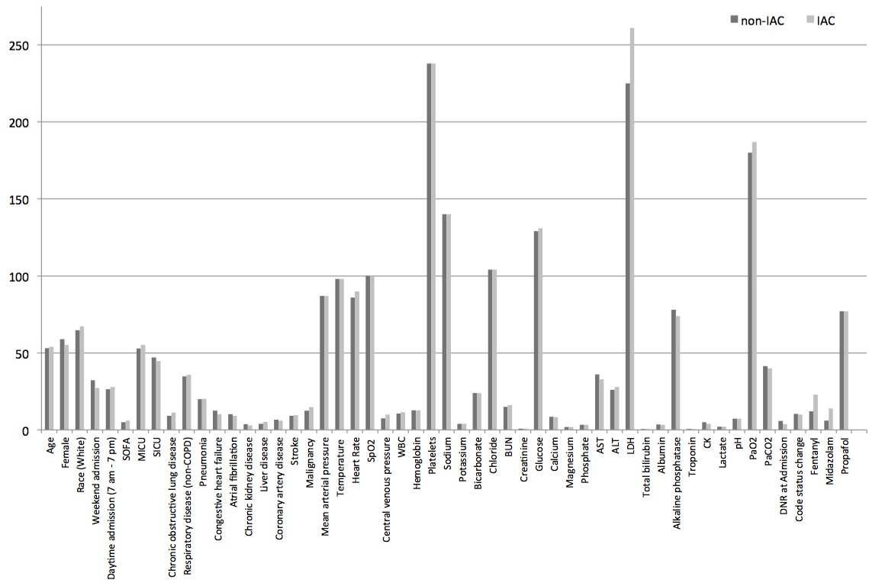

eFigure 1. Baseline covariate distributional balance in propensity-matched cohorts

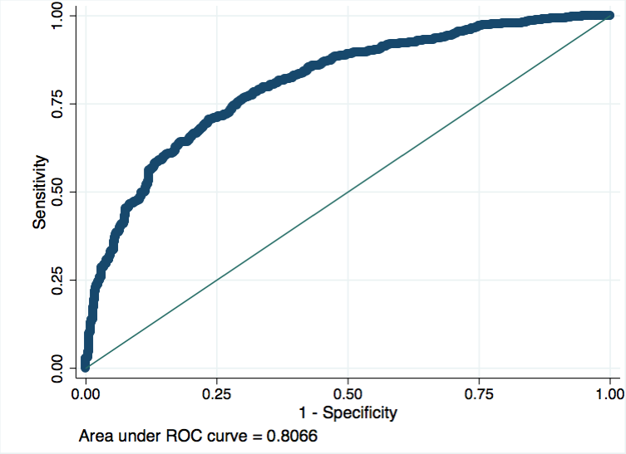

eFigure 2. Average ROC curve of the finalized Propensity Score Model over 10-fold cross-validation.

**A.4 Sensitivity Analyses – Propensity Score Weight Method**

We used propensity score weights (PSW) to do a weighted regression for outcome estimation [4, 5]. The PSW were generated by an algorithm that aimed at optimizing post-weighting balance of covariates between the treatment and the control group. Some covariates stayed imbalanced after weighting, and were adjusted for in the weighted regression model without further variable selection, thus providing a robust estimation for the outcome.

A machine learning-based generalized boosted model (GBM) was used for the estimation and evaluation of propensity scores and associated PSW. GBM fitted a piecewise constant model to predict a dichotomous outcome, i.e. the treatment assignment. The iterative fitting algorithm built a regression tree that provided increasing log likelihood for the data with increasing iteration. During the iterative process, the PSW generated after each iteration were evaluated by calculating the standardized bias across all covariates of the weighted data. An iteration number that minimized the mean standardized bias across all covariates, i.e. maximized the balancing of covariates between the treatment and the control group, was chosen for generating the final PSW.

**A.5 Sensitivity Analyses – Multivariate Logistic Regression**Utilizing both the original GA-derived matched cohorts, as well as the PSW-derived matched cohorts, we then estimated logistic regression models for 28-day mortality including any imbalanced baseline covariates (including those not retained in final propensity score models). There was no significant differences in 28-day mortality between the IAC and non-IAC groups (eTable 2).

**eTable 3. Weighted logistic regression model for 28-day mortality**

|  |  |  |  |
| --- | --- | --- | --- |
|  | OR | 95% Confidence Interval | p-value |
| GA Method | 0.93 | 0.61, 1.44 | 0.75 |
| PSW Method | 1.39 | 0.63, 3.06 | 0.41 |

* Reference group - Non-IAC

**eTable 4. Comparison of candidate covariates between matched and unmatched cohorts**

|  |  |  |  |  |  |  |
| --- | --- | --- | --- | --- | --- | --- |
| **Variables** | **Non-IAC** | | | **IAC** | | |
| **Matched (n=348)** | **Unmatched (n=636)** | **p-value** | **Matched (n=348)** | **Unmatched (n=444)** | **p-value** |
| Age (year) | 53 (35-72) | 49 (34-71) | 0.1 | 54 (38-73) | 58 (41-74) | 0.1 |
| Female | 205 (58.9%) | 256 (56.1%) | 0.8 | 192 (55.2%) | 394 (60.7%) | 0.1 |
| White race | 225 (64.7%) | 333 (72.8%) | 0.2 | 234 (67.3%) | 459 (70.7%) | 0.8 |
| Daytime admission (7am-7pm) | 92 (26.4%) | 148 (32.3%) | 0.1 | 97 (27.9%) | 190 (29.2%) | 0.9 |
| Weekend admission | 112 (32.2%) | 140 (30.6%) | 0.4 | 95 (27.3%) | 161 (24.8%) | 0.3 |
| SOFA Score | 5 (4-7) | 4 (3-5) | <0.0001 | 6 (4-7) | 7 (5-8) | <0.0001 |
| **Service Unit** |  |  | <0.0001 |  |  | <0.0001 |
| MICU | 184 (52.9%) | 328 (71.7%) | 192 (55.2%) | 103 (15.9%) |
| SICU | 164 (47.1%) | 129 (28.2%) | 156 (44.8%) | 546 (84.1%) |
| **Co-incident Diseases** |  |  |  |  |  |  |
| Congestive heart failure | 44 (12.6%) | 60 (13.1%) | 0.4 | 36 (10.3%) | 75 (11.6%) | 0.8 |
| Atrial fibrillation | 36 (10.3%) | 45 (9.9%) | 0.6 | 32 (9.2%) | 88 (13.6%) | 0.3 |
| Chronic renal disease | 13 (3.8%) | 18 (4%) | 0.6 | 10 (2.9%) | 22 (3.4%) | 0.9 |
| Liver Disease | 14 (4%) | 20 (4.4%) | 0.6 | 18 (5.2%) | 45 (6.9%) | 0.2 |
| Chronic obstructive pulmonary disease | 32 (9.2%) | 43 (9.4%) | 0.4 | 39 (11.2%) | 40 (6.2%) | 0.02 |
| Coronary artery disease | 23 (6.6%) | 27 (6%) | 0.6 | 21 (6%) | 56 (8.6%) | 0.03 |
| Stroke | 32 (9.2%) | 37 (8.1%) | 0.4 | 33 (9.5%) | 118 (18,2%) | 0.001 |
| Malignancy | 44 (12.6%) | 46 (10.1%) | 0.1 | 51 (14.7%) | 125 (19.3%) | 0.0002 |
| Respiratory disease (non-COPD) | 121 (34.7%) | 157 (34.4%) | 0.7 | 125 (35.9%) | 158 (24.4%) | <0.0001 |
| Pneumonia | 67 (20%) | 89 (17.5%) | 0.4 | 68 (20.3%) | 84 (12.9%) | 0.003 |
| **Vital Signs** |  |  |  |  |  |  |
| Weight (Kg) | 75 (65-90) | 76 (65-89) | 0.9 | 78 (65-90) | 78 (67-90) | 0.7 |
| Mean arterial pressure (mmHg) | 87 (77-98) | 86 (77-97) | 0.99 | 87 (75-98) | 88 (76-101) | 0.2 |
| Temperature (F) | 98 (97-99) | 98 (97-99) | 0.2 | 98 (97-99) | 98 (97-99) | 0.3 |
| Heart Rate | 86 (74-100) | 88 (76-101) | 0.2 | 90 (77-99) | 86 (73-100) | 0.1 |
| SpO2 (%) | 100 (98-100) | 100 (98-100) | 0.1 | 100 (99-100) | 100 (99-100) | 0.3 |
| Central venous pressure (mmHg) | 7.5 (6-12) | 8.5 (6-11) | 0.7 | 10 (6-13) | 10 (6-13) | 0.5 |
| **Laboratory Tests** |  |  |  |  |  |  |
| White blood cell count (K/uL) | 10.7 (8-14.8) | 10.6 (7.6-14.1) | 0.3 | 11.5 (8.4-14.7) | 11.8 (8,7-16.4) | 0.2 |
| Hemoglobin (g/dL) | 12.8 (11.2 -14.2) | 13 (11.4-14.4) | 0.1 | 12.7 (11-14.1) | 12.3 (10.8-13.9) | 0.02 |
| Platelets (K/uL) | 238 (184-303) | 247 (199-307) | 0.09 | 238 (186-289) | 228 (165-291) | 0.05 |
| Sodium (mEq/L) | 140 (138-143) | 140 (138-143) | 0.12 | 140 (137-142) | 139 (137-142) | 0.01 |
| Potassium (mEq/L) | 4 (3.6-4.5) | 4 (3.7-4.4) | 0.5 | 4 (3.7-4.4) | 4 (3.6-4.4) | 0.5 |
| Bicarbonate (mEq/L) | 24 (22-27) | 25 (22-28) | 0.02 | 24 (21-27) | 24 (21-27) | 0.22 |
| Chloride (mEq/L) | 104 (100-107) | 103 (100-106) | 0.1 | 104 (100-107) | 105 (101-108) | 0.02 |
| Blood urea nitrogen (mg/dL) | 15 (11-22) | 15 (11-21) | 0.5 | 16 (12-22) | 16 (12-22) | 0.6 |
| Creatinine (mg/dL) | 0.9 (0.7-1.2) | 0.9 (0.7-1.1) | 0.2 | 0.9 (0.7-1.1) | 0.9 (0.7-1.1) | 0.2 |
| Glucose (mg/dL) | 129 (107-157) | 124 (104-164 | 0.4 | 131 (109-171) | 137 (112-171) | 0.2 |
| Calcium (mg/dL) | 8.5 (8-9) | 8.6 (8.1-9.1) | 0.1 | 8.4 (7.9-8.9) | 8.4 (7.8-8.9) | 0.4 |
| Magnesium (mg/dL) | 1.8 (1.6-2) | 1.9 (1.7-2.1) | 0.01 | 1.8 (1.6-2.1) | 1.7 (1.5-2) | 0.03 |
| Phosphate (mg/dL) | 3.3 (2.7-4) | 3.3 (2.7-3.9) | 0.8 | 3.4 (2.7-4.1) | 3.4 (2.9-4.1) | 0.3 |
| Aspartate transaminase (IU/L) | 36 (23 -67) | 29 (21-51) | 0.01 | 33 (21-67) | 40 (24-92) | 0.02 |
| Alanine transaminase (IU/L) | 26 (17-48) | 34 (16-42) | 0.3 | 28 (17-51) | 30 (17-64) | 0.3 |
| Lactate dehydrogenase (IU/L) | 225 (188-319) | 230 (184-291) | 0.5 | 261 (199-377) | 270 (210-384) | 0.3 |
| Total Bilirubin (mg/dL) | 0.5 (0.3-1) | 0.5 (0.3-0.7) | 0.2 | 0.6 (0.3-0.9) | 0.7 (0.4-1.2) | 0.0007 |
| Alkaline phosphatase (IU/L) | 78 (59-108) | 78 (61-101) | 0.9 | 74 (57-99) | 78 (59-112) | 0.13 |
| Albumin (g/dL) | 3.6 (3.1-3.9) | 3.7 (3.2-4.1) | 0.05 | 3.4 (2.9-3.8) | 3.1 (2.8-3.7) | 0.01 |
| Troponin T (ng/mL) | 0.05 (0.03-0.15) | 0.04 (0.02-0.1) | 0.1 | 0.04 (0.02-0.16) | 0.05 (0.02-0.11) | 0.9 |
| Creatinine kinase (ng/mL) | 5 (3-9) | 5 (3-8) | 0.7 | 4 (3-8.5) | 5 (4-10) | 0.2 |
| Brain natriuretic peptide (pg/mL) | NA | NA | NA | NA | NA | NA |
| Lactate (mmol/L) | 2 (1.3-2.9) | 2.2 (1.5-3.1) | 0.1 | 2.2 (1.5-3.4) | 1.9 (1.4-3.1) | 0.1 |
| pH | 7.37 (7.32-7.43) | 7.4 (7.3-7.4) | 0.3 | 7.37 (7.3-7.42) | 7.38 (7.3-7.4) | 0.1 |
| SvO­­2 | NA | NA | NA | NA | NA | NA |
| PaO2 (mmHg) | 180 (104-340) | 174 (87-341) | 0.2 | 187 (106-300) | 205 (122-326) | 0.2 |
| PaCO2 (mmHg) | 41.5 (37-47) | 42 (37-49) | 0.06 | 40 (35-46.5) | 40 (35-45) | 0.2 |
| **Sedative Medications Used** |  |  |  |  |  |  |
| Fentanyl | 43 (12%) | 40 (9%) | 0.08 | 79 (23%) | 145 (22%) | 0.7 |
| Midazolam | 22 (6%) | 33 (7%) | 0.8 | 48 (14%) | 47 (7%) | 0.001 |
| Propofol | 259 (77%) | 265 (58%) | <0.0001 | 259 (77%) | 515 (79%) | 0.5 |

* Insufficient number of matched pairs for brain natriuretic peptide and SvO2 comparisons

**References**:

[1] Mitchell, Melanie (1996). An Introduction to Genetic Algorithms. Cambridge, MA: MIT Press.

[2] <http://cran.r-project.org/web/packages/GA/index.html>

[3] Ridgeway G, McCaffrey D, Morral A, Ann B, and Burgette L (2015). Twang: Toolkit for Weighting and Analysis of Nonequivalent Groups. R package version 1.4-9.3. <http://CRAN.R-project.org/package=twang>

[4] McCaffrey D, Ridgeway G, Morral A (2004). “Propensity Score Estimation with Boosted Regression for Evaluating Adolescent Substance Abuse Treatment,” Psychological Methods 9(4):403-425.

[5] Brian K. Lee, Justin Lessler, and Elizabeth A. Stuart (2010). “Improving propensity score weighting using machine learning,” Stat Med. 2010 February 10; 29(3): 337–346